**Settlers of Mars Specifications**

**Introduction:**

|  |  |
| --- | --- |
| Name | Job |
| Mark Grayson | Manager |
| Mark Ma | Research Specialist |
| Chad Davis | Programmer / Blockchain supervisor |
| David Kapanga | Programmer / Hardware specialist |
| Johnny Zhang | Programmer |
| Dan G | Programmer Audio Engineer/ Media Consultant |
| Katie Mowris | Assistant Manager / Lead Designer / Programmer |

(Teammate jobs to be decided, GUI and other specifics)

This document discusses the creation on an online board game derived from the Settlers of Catan framework and transposed into a derived game known as Settlers of Mars.

**Purpose:**

The purpose of this document is to serve as a guide to designers, developers, and testers who are responsible for the engineering of the Settlers of Catan online board game project. It should give engineers all of the information necessary to design, develop, and test the software.

**Scope:**

This document contains a portion of the project description and functionalities of Settlers of Catan online board game. It consists of some but not all use cases, functional requirements, and non-functional requirements that together form a semi-complete description of the software.

**System Overview**

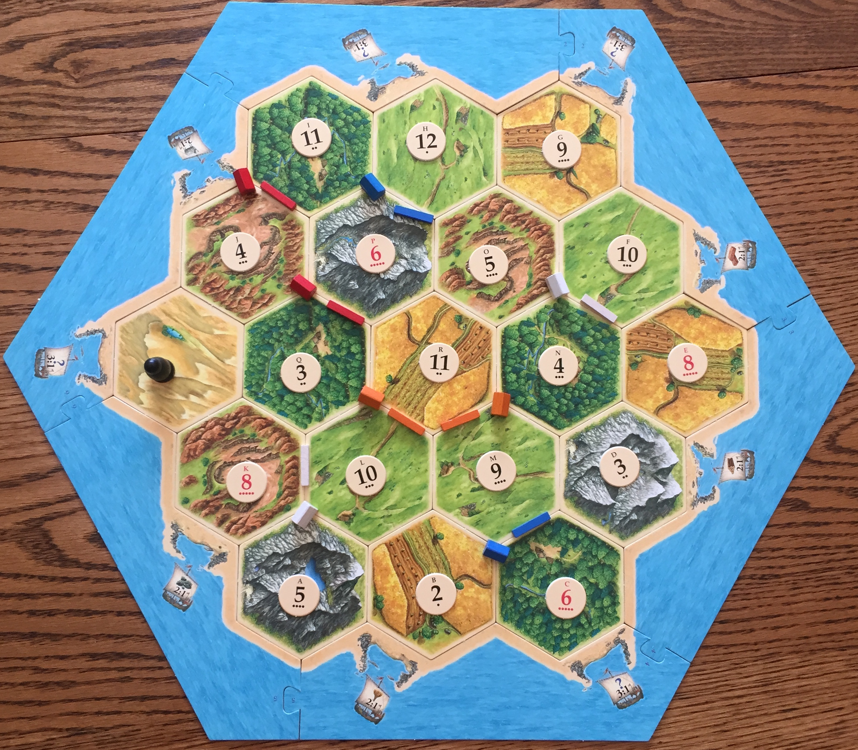

(Settlers of Catan)

*Game* :

The game is essentially a 3-4 person board game that plays on Settlers of Catan, and uses all the rules from the base game. Players take turns rolling dice to determine which region generates resources, trading resources amongst themselves, and building settlements, cities, and roads all to gain victory points. The first player to reach 10 victory points wins. The board game is a hexagonal board that consists of hexes as the resources and numbered tiles that displays the probability to roll the depicted number, and the depicted number that defines what number needs to be rolled each turn to collect said resource. A player who builds on the intersection of three hexes will be allotted the resources the players’ pieces border. Each turn the player who rolls the dice has the ability to gain resources, and trade either with the bank, or other players. The player then also has the choice to purchase cities, settlements, roads and development cards that contribute to gaining the 10 necessary victory points to win. The hexes consist of plastic, steel, hemp, glass, and soy in the revised version, called Settlers of Mars. The trading ports are now trading posts, and the knight/robber is now a sand storm.

*Turn Overview:*

Players on each turn can do the following:

* The player must roll for resource production
* The player may trade resources with other players, the bank or between trade posts
* The player may build roads, settlements, cities, and/or buy development cards. As well as play one development card at any time during a turn.

**Resource Production**: The sum of the dice at the beginning of any players turn determines which terrain hexes produce resources. Settlements produce 1 resource for each player whose settlement borders that specific resource. Cities produce 2 of that same resource.

**Trade**: Each turn players can trade Resource cards with any other players however many times they wish. Both the player and the other players making offers determine this and can accept, decline or counter offers with the players whose turn it is. The player can also trade with the bank at a 4:1 ratio. Placing 4 identical Resource Cards back in the stack of the bank for 1 Resource card of the players choosing. If the player has a settlement or city stationed at a trading post the player can trade at either a 3:1 or 2:1 ratio.

**Build**: Building increases victory points, expands road network, improves resource production, and/or buy Development Cards. Players can build up to but not exceeding 5 settlements, 4 cities, and 15 roads.

Road(requires glass and plastic): Road must connect to an existing city or settlement. First player to build a continuous road of at least 5 road segments gets a Special Card “longest road” that counts for two victory points. If a longer road is created by another player this card will be overturned to them.

Settlement(requires glass, plastic, hemp, soy): These can only be built at an intersection that has 3 adjacent intersections that are empty. Each settlement produces 1 Resource card when that terrain hexes number is rolled.

City(requires 3 steel and 2 soy): Can only establish by upgrading a settlement. Each city produces 2 Resource Cards when that terrain hexes number is rolled.

Development Cards(require steel, hemp, soy): Draw top card from deck. Three types of cards 1) Knight 2) Progress 3)Victory Points. These never go back into the supply and cannot buy if empty.

1) Knight: Acts in two ways. One it allows the player to move the sand storm to any hex on the board. Then the player can steal one Resource Card from the adjacent players who have a city or settlement adjacent to the hex. Two the player who has three knight cards receives the special card “largest army”. Like “longest road” the player receives 2 victory points and it can be overturned to a player who exceeds this number of knights.

2) Progress Cards: These have instructions that have to be played and then it is removed from the game.

a) Year of plenty: Draw two Resource Cards of choice from bank.

b) Road building: Can place 2 roads as if they just built them

c) Monopoly: Player can claim all resource cards of a specific type from the bank.

3) Victory Point: Keep these hidden. These are reveled only during your turn and when you have 10 victory points.